CTL DECISION SHEET (DSH)

Standard(s) (incl. year) | Subclause(s) | No. | Year
IEC60065: 2005 (ed7.1) | 19.2 | 1082 | 2013
Category | 19.2 | 1082 | 2013
TRON | 19.2 | 1082 | 2013
Subject | Keywords | Developed by | Approved at
Vertical force test | - unfavourable position | ETF 2 | 2014 CTL Plenary Meeting
Question
When the vertical force test is performed, shall the sample be placed in the most unfavourable
position (i.e. at the edge of the supporting surface)?
Example:
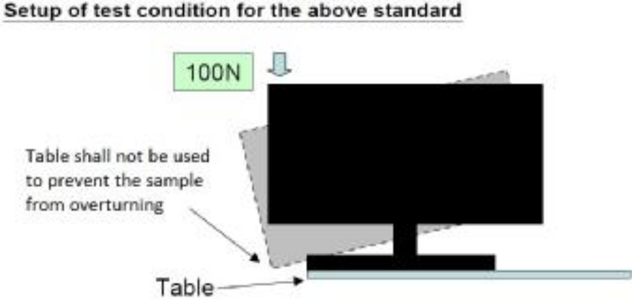
Note: IEC 60065: 2010 (am2, ed 7.0) has clearly stated the test condition, and this interpretation shall
also be applied in IEC60065: 2005 (ed 7.1)?
Decision
The table shall not be used to prevent the sample from overturning when a force of 100N is applied vertically downwards, therefore the sample shall be placed towards the edge of the table (non-skid surface).
Explanatory notes
As IEC 60065: 2010 (am2, ed 7.0) was issued to clarify the situation of the test, this interpretation should also be used for the previous edition.

